**Software Requirement Specifications**

**<Pest Prediction System >**

Version 1.0



**Submitted by**

Farhan Jamal

(F24BINFT7M04020)

Syed Jahanzaib

(F24BINFT7M04022)

**Submitted to**

Ma’am Musarat Karim

**Department of Information Technology**

**Faculty of Computing**

**The Islamia University of Bahawalpur**

**Meeting Details**

|  |  |  |  |
| --- | --- | --- | --- |
| **Sr No** | **Details** | **Date** | **Supervisor Signature** |
|  |  |  |  |
|  |  |  |  |
|  |  |  |  |
|  |  |  |  |
|  |  |  |  |
|  |  |  |  |
|  |  |  |  |
|  |  |  |  |
|  |  |  |  |
|  |  |  |  |

**Summary**

The Pest Prediction System is an IoT-based smart agriculture solution designed to detect early pest infestation using environmental sensor data, drone-captured imagery, and AI-based prediction models. The system consists of two main components: ground sensor mount stands placed at different corners of the field, and a drone equipped with a high-resolution camera and a Raspberry Pi 5 performing automated scanning flights. Sensor data and drone images are processed through AI models to predict pest risks and immediately notify the farmer through a Flutter-based mobile application. The mobile app also provides drone control options and displays alert notifications and dashboard analytics. This SRS document provides complete functional and non-functional requirements, use cases, diagrams, and subsystem design.

**Table of Contents**

**1.** **Introduction** 5

**1.1.** **Purpose** 5

**1.2.** **Scope** 5

**1.3.** **Product Perspective** 6

**1.4.** **User Characteristics** 10

**1.5.** **Similar apps and systems/Literature Review** 10

**1.6.** **Proposed Technologies** 10

**2.** **Requirements** 10

**2.1.** **Function Requirements** 11

**2.2.** **Non-Functional Requirements** 12

**3.** **Use Cases and Flow of Processes** 15

**3.1.** **System Level Use Case Diagram** 16

**3.2.** **System Level Use Case Description**  18

**3.3.**  **Mobile Use Case Diagram** 23

**3.4.** **Mobile Use Case Description** 24

**4.** **References** 29

1. **Introduction**

The Pest Prediction System aims to support farmers by providing automated pest monitoring without requiring manual inspection of fields. The system is developed as a standalone IoT + AI solution that uses Raspberry Pi 5 for drone processing, ESP32-based sensor stands for soil and environmental data collection, and a cloud backend for storage and model evaluation. The system integrates real-time drone control, data visualization, alerts, and prediction services through a mobile app built using Flutter. This introduction outlines the need for a precise pest monitoring system to reduce crop damage and increase productivity through timely decision-making.

* 1. **Purpose**

The purpose of this system is to automate pest detection and risk prediction by utilizing sensor readings, drone imagery, and a cloud-based AI engine. The system notifies the farmer immediately through the mobile app when potential pest activity is detected so preventive action can be taken. It also improves efficiency by eliminating manual field inspection and provides accurate prediction using both visual and environmental indicators.

* 1. **Scope**

The project covers the development of an IoT pest prediction system with drone

integration, sensor stands, mobile application, and cloud backend. It includes drone

navigation control, image capturing, data processing, risk prediction, alert notification and dashboard visualization.

The system **does include**:

* Mobile app for drone control and alerts.
* Drone-based image capturing.
* Sensor stands for environmental monitoring.
* AI-based pest prediction.
* Cloud database and dashboard.

The system **does not include**:

* Manual pesticide spraying.
* Drone mapping and advanced GIS features.
* Multiple-field enterprise management.
  1. **Product Perspective**

The Pest Prediction System integrates multiple smart components to create a unified precision-agriculture ecosystem. It extends traditional farming by introducing automation, continuous monitoring, and AI-driven decision support. The mobile application serves as the central access point for the farmer, enabling drone control, alert viewing, dashboard analysis, and device health monitoring. The drone provides aerial imaging of crop areas, capturing high-resolution pictures that help detect early signs of pest activity. The IoT sensor mount stands act as fixed ground-level monitoring units that continuously measure soil and environmental parameters such as temperature, humidity, soil moisture, sunlight intensity, and weather conditions. These sensor and image data streams are collected by the Raspberry Pi and processed through a cloud-based prediction engine that generates reliable pest-risk assessments..

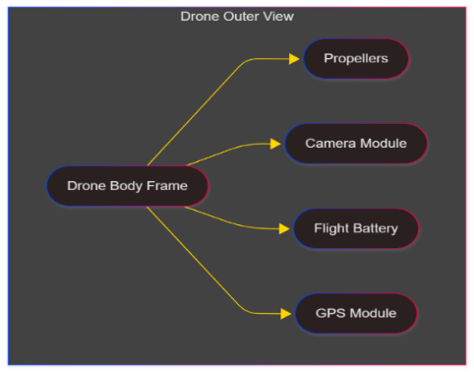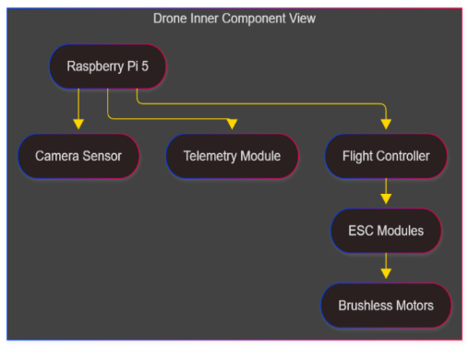

Figure1.3 (a) Drone Outer View Figure1.3 (b) Drone inner View



Figure 1.3 (c) 3D image of drone

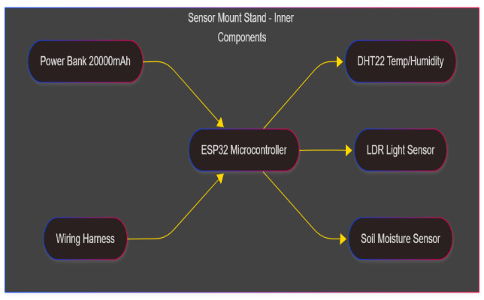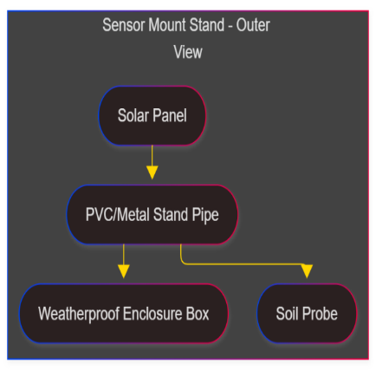

Figure1.3 (d) Mount stand Outer View Figure1.3 (e) Mount stand Outer View

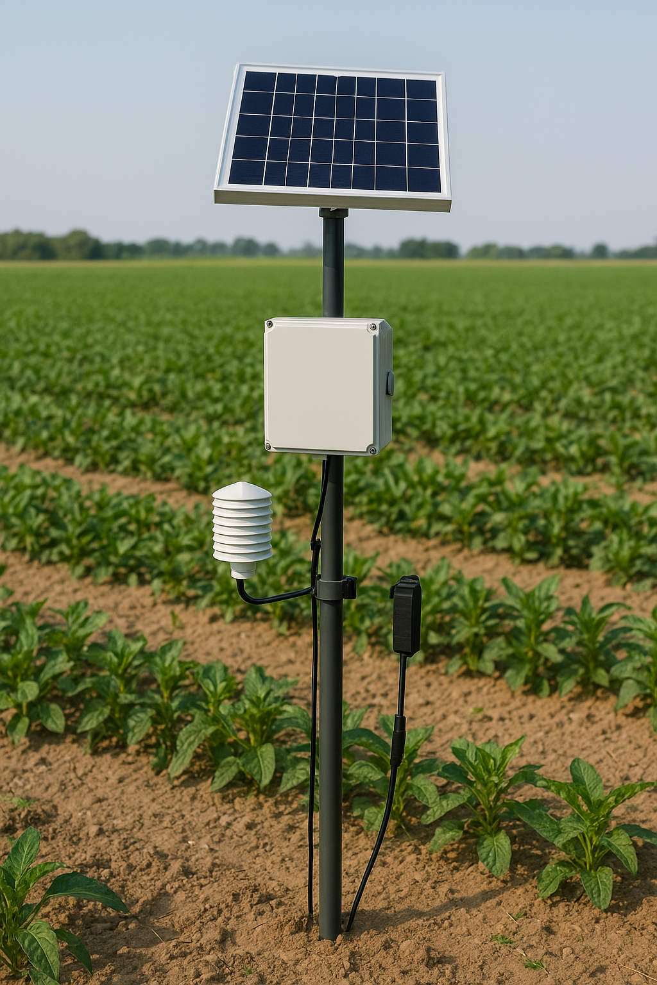

Figure 1.3 (f) 3D image of Mount stand

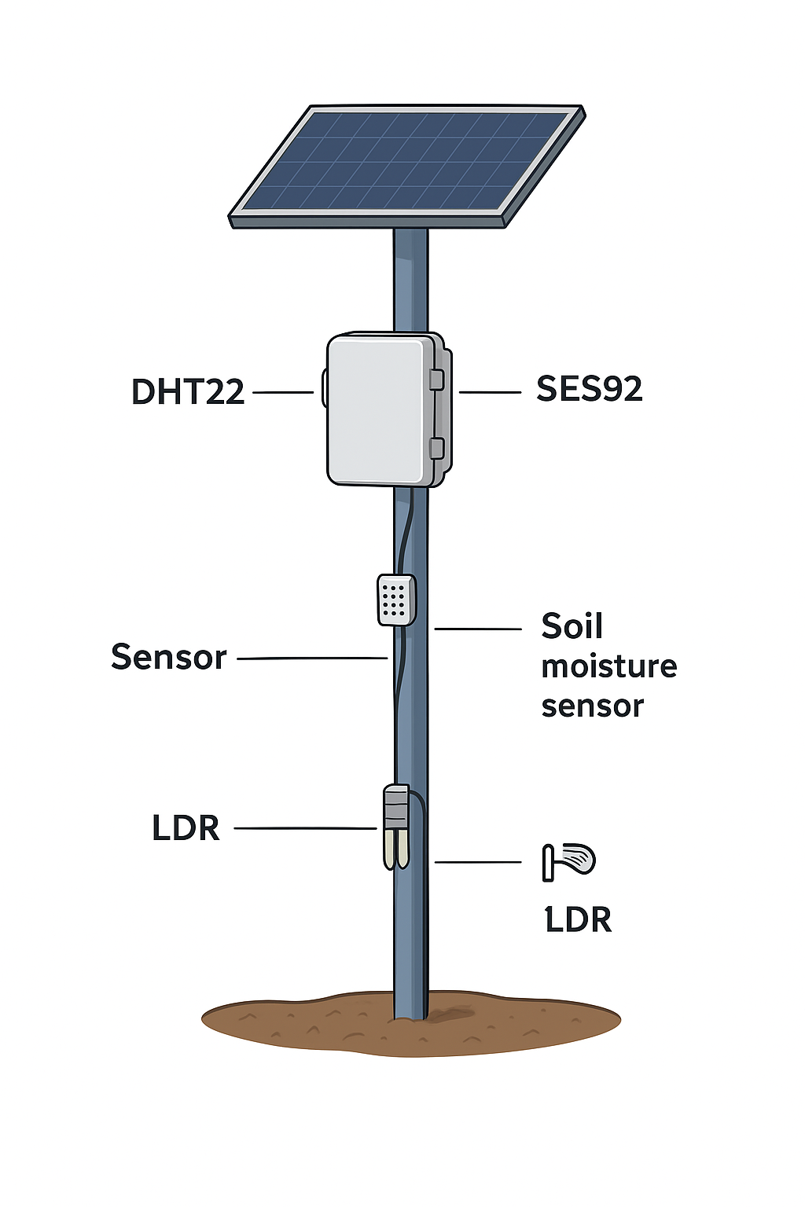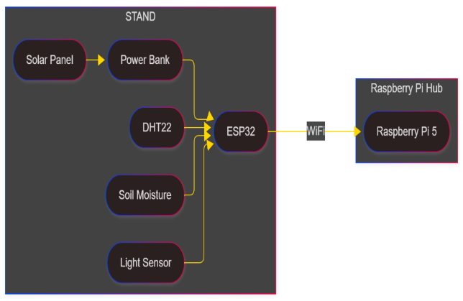

Figure 1.3 (h) Stand + wiring Figure 1.3 (i) 3D image Stand +wiring

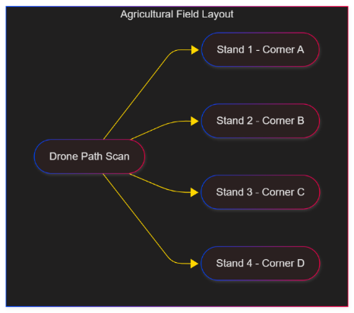

Figure 1.3 (j) Field Layout Figure 1.3 (k) 3D Image of Filed Layout

* 1. **User Characteristics**

The primary user of this system is a farmer who may possess basic understanding of smartphone usage but may not have technical expertise in IoT or drones. The mobile application is designed for easy navigation, clear visual indicators, and simple drone control buttons. Advanced settings are hidden to reduce complexity.

* 1. **Similar apps and systems/Literature Review**

Existing solutions such as DroneDeploy, Climate FieldView, and agricultural pest monitoring applications provide partial functionality, such as drone flight automation or weather-based predictions. However, these systems usually do not integrate both drone imagery and real-time sensor data. Academic literature shows increasing use of CNN-based pest classification models and IoT sensor networks for improved monitoring. The proposed system improves upon existing solutions by combining IoT sensors and drone-based real-time imagery to deliver early, accurate pest detection.

* 1. **Proposed Technologies**

The system uses a combination of hardware and software technologies.

– Hardware: Raspberry Pi 5 (drone), ESP32 (stands), DHT22, Soil Moisture Sensor, LDR, Solar Panel, Power Bank

– Software: Flutter (mobile app), Python (backend + AI), Firebase/S3 (storage), MQTT/HTTPS (communication), TFLite (AI models), Raspberry Pi OS

1. **Requirements**

The Pest Prediction System enables real-time pest monitoring through sensor data collection and drone imagery. The system stores, processes, and analyzes this data to produce risk alerts. The farmer uses the mobile app to initiate drone flights, monitor fields, and view analytics through the dashboard. The app’s notification system ensures immediate awareness of pest presence, improving timely decision-making.

* 1. **Function Requirements**

### **FR01 — Sensor Data Collection**

|  |  |
| --- | --- |
| **Purpose** | Collects moisture, temperature, humidity, and light intensity from the sensor stands |
| **User(s)** | System |
| **Input** | Sensor readings from ESP32 |
| **Output** | JSON data stored in cloud backend |

**FR02 — Drone Image Capture & Upload**

|  |  |
| --- | --- |
| **Purpose** | Drone automatically captures images during flight and uploads them to cloud storage |
| **User(s)** | Farmer |
| **Input** | Drone camera data |
| **Output** | Stored images + metadata |

**FR03 — AI Pest Prediction Engine**

|  |  |
| --- | --- |
| **Purpose** | Analyze images + sensor data to predict pest infestation risk |
| **User(s)** | System |
| **Input** | Sensor data + drone images |
| **Output** | Pest risk score + detection results |

**FR04 — Alert Notifications**

|  |  |
| --- | --- |
| **Purpose** | Send real-time notifications to farmer in the app. |
| **User(s)** | Farmer |
| **Input** | High/Medium risk from model |
| **Output** | Flutter push notification |

**FR05 — Drone Control via Mobile App**

|  |  |
| --- | --- |
| **Purpose** | Allow user to control drone using Flutter app buttons (Takeoff, Land, Capture) |
| **User(s)** | Farmer |
| **Input** | Button commands |
| **Output** | Button commands |

**FR006 — Dashboard View**

|  |  |
| --- | --- |
| **Purpose** | Display historical sensor values, captured images, predictions, and alerts. |
| **User(s)** | Farmer |
| **Input** | Fetched cloud data |
| **Output** | Dashboard analytics |

* 1. **Non-Functional Requirements**

The system must be reliable, scalable, and user-friendly. It must operate under low connectivity conditions and support secure data transmission through encryption. The mobile interface should be responsive and easy to use for farmers. The system should process predictions with minimal delay and handle drone control commands safely.

**2.2.1 Reliability**

The system must be highly reliable, ensuring continuous operation in agricultural environments where temperature, dust, humidity, and lighting conditions vary throughout the day. The drone and sensor stand must sustain reliable performance during mission execution, even when subjected to moderate wind or momentary network fluctuations. The Raspberry Pi should maintain stable communication with the drone flight controller, while the sensor stand must consistently send readings without frequent resets or failures. In the case of temporary disconnections, the system should automatically recover and continue data collection without user intervention.

**2.2.2 Performance and Responsiveness**

The system must respond promptly to user commands, particularly during manual drone control. The delay between pressing a control button in the mobile app and the actual drone movement should be minimal to maintain precise control and safe operation. The data synchronization between the sensor stand and the Raspberry Pi must also occur efficiently so that real-time information is available for prediction. The dashboard within the mobile app should load charts, images, and alerts in a timely manner to avoid interrupting the farmer’s workflow.

**2.2.3 Security**

The system must ensure secure communication and data protection across all components. Communication between the mobile app, Raspberry Pi, and cloud must be encrypted to prevent unauthorized access or manipulation of data. User credentials must be stored securely within the authentication module, while images, sensor readings, predictions, and alert logs must be protected through appropriate access control rules. The system should restrict unauthorized modification of drone commands or device configurations.

**2.2.4 Usability**

The mobile application must be designed to be extremely user-friendly because the primary users are farmers who may not be familiar with complex interfaces. All essential functions such as drone control, mission start, alert viewing, dashboard analysis, and device status monitoring must be accessible with clear labels and a simple layout. The interface should operate smoothly even on mid-range Android devices commonly used in rural areas. Visual clarity must be maintained in charts, images, and alerts to ensure meaningful interpretation.

**2.2.5 Accuracy of Prediction**

The AI-based pest prediction engine must produce reliable and accurate risk levels by processing environmental sensor data and drone-captured images. The model must handle variations in lighting, partial occlusions in images, and inconsistent sensor readings without producing unrealistic outcomes. The predicted risk classification (Low, Medium, High) must reflect actual field conditions as closely as possible so farmers can depend on the system for early pest management.

**2.2.6 Battery Efficiency**

The system must ensure efficient power consumption across all hardware components. The drone must complete its scanning mission within the available battery capacity, while the IoT sensor stand should operate through a combination of solar power and a power bank. The Raspberry Pi should efficiently manage its processing tasks to avoid excessive energy drain during image processing or sensor data handling. Proper sleep cycles and update intervals should ensure long-term field deployment without frequent maintenance.

**2.2.7 Scalability**

The architecture must support easy scalability as farm size grows or additional fields are added. The system should allow the installation of more sensor stands, additional drones, or new Raspberry Pi nodes without requiring redesign. The cloud backend should handle increasing data loads, including large volumes of images and continuous sensor values. The mobile app must be able to switch between multiple fields and devices seamlessly.

**2.2.8 Maintainability**

The system must be maintainable so technicians can inspect, replace, or upgrade components without disrupting operation. The sensor stand’s internal design must allow easy replacement of sensors, wires, or the ESP32 module. The drone should allow replacement of camera modules, batteries, or flight components. Moreover, the software

modules such as the mobile application, AI model, and Raspberry Pi services must support updates through modular design.

**2.2.9 Fault Tolerance**

The system must continue functioning even when individual components temporarily fail. If the sensor stand stops sending data, the Raspberry Pi must store the previous readings and alert the farmer through the mobile app’s device status menu. If the drone loses network connectivity during a mission, it must rely on local instructions and return safely using GPS-based fail-safe settings. The prediction engine must work even when some data points are missing by using fallback logic to avoid service disruption.

**2.2.10 Availability**

The system should be available whenever the farmer needs to use it, particularly during early morning or evening scanning hours. Server downtime must be minimized through stable cloud hosting. The mobile application should be accessible offline for viewing cached data, even if real-time updates are temporarily not possible.

1. **Use Cases and Flow of Processes**

This section describes all interactions that take place between users and the system components, including the drone, sensor stand, cloud prediction engine, and mobile application. The use case models provide a structural and behavioral overview of how the entire Pest Prediction System operates. The system includes two major operational layers: the overall system layer, which handles drone operations, sensor data collection, prediction processing, device health, and system alerts, and the mobile application layer, which enables the farmer to control the drone, view alerts, access dashboards, and monitor device status. Both layers are presented with separate use case diagrams to maintain clarity and structure.

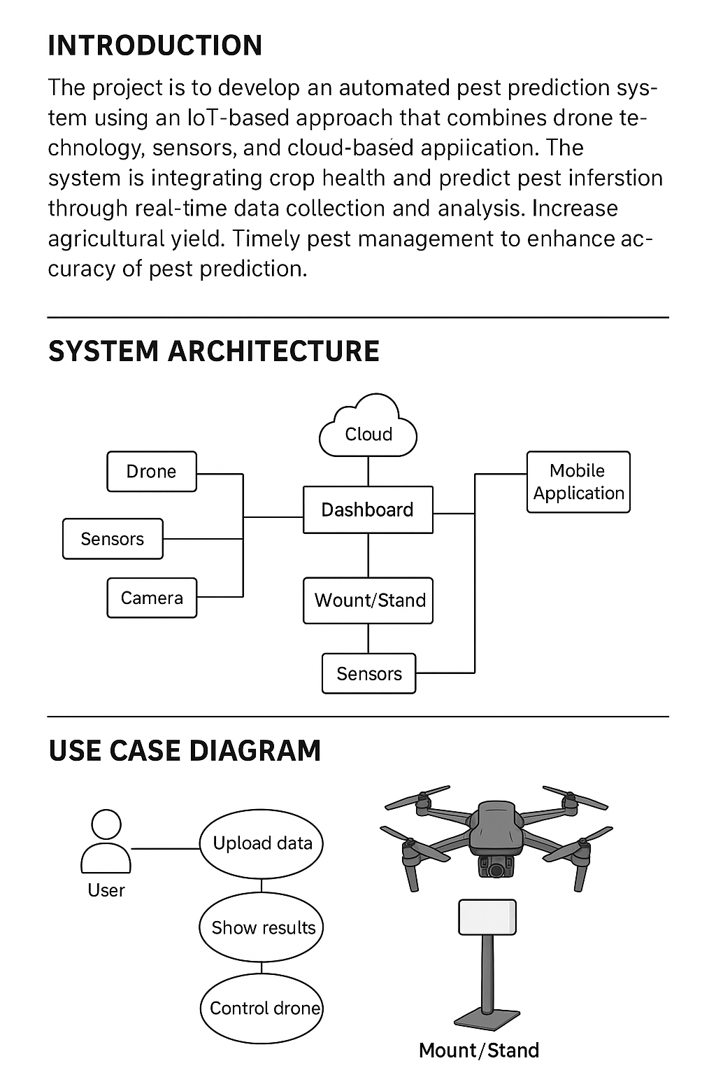

* 1. **System-Level Use Case Diagram**

The system-level use case diagram shows how the farmer interacts with different components of the pest prediction system, including the drone, the Raspberry Pi module, the IoT sensor stand, the cloud-based prediction engine, and the device health monitoring subsystem

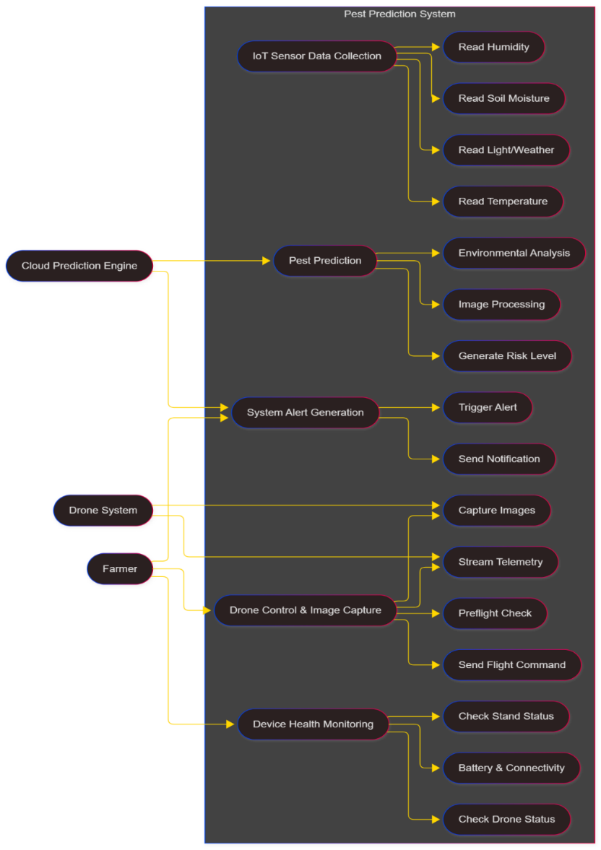

Figure 3.1 – System-Level Use Case Diagram

* 1. **System-Level Use Case Descriptions**
     1. **System Use Case : Drone Control & Field Scanning**

| **Field** | **Description** |
| --- | --- |
| **Use Case ID** | UC-01 |
| **Use Case Name** | Drone Control and Field Scanning |
| **Actor** | Farmer, Drone System, Raspberry Pi |
| **Precondition** | Drone is powered on; Raspberry Pi is connected to flight controller; GPS signal is available; battery level is safe for flight. |
| **Postcondition** | Drone completes scanning mission; images and telemetry are stored and uploaded to the cloud. |
| **Basic Flow** | The farmer initiates a drone mission using the mobile application. The Raspberry Pi performs preflight checks and sends movement commands to the drone. The drone flies autonomously or manually, capturing images and transmitting telemetry back to the Pi. After mission completion, data is saved locally and synchronized to the cloud for analysis. |
| **Alternative Flow** | The farmer selects an automatic predefined mission pattern (grid, circular, waypoint). The drone completes it without step-by-step control input. |
| **Exceptions** | GPS loss, low battery, remote link interruption, or sensor failure triggers the drone’s auto-return or safety behavior. |

* + 1. **System Use Case : IoT Sensor Data Collection**

| **Field** | **Description** |
| --- | --- |
| **Use Case ID** | UC-02 |
| **Use Case Name** | IoT Sensor Stand Data Collection |
| **Actor** | Sensor Stand (ESP32), Raspberry Pi, Cloud Server |
| **Precondition** | Sensor stand is powered via solar; sensors (temperature, humidity, moisture, weather) are functional; wireless communication link is active**.** |
| **Postcondition** | Environmental readings are successfully stored on the Raspberry Pi and synchronized with cloud storage. |
| **Basic Flow** | The IoT stand collects sensor readings at fixed intervals. The ESP32 transmits them to the Raspberry Pi using MQTT/HTTP. The Pi validates and stores the data before sending it to the cloud. |
| **Alternative Flow** | If communication is weak, readings are temporarily stored in local memory and sent later when the connection stabilizes. |
| **Exceptions** | Sensor malfunction, solar power failure, ESP32 reboot, or packet corruption triggers a device health warning. |

* + 1. **System Use Case : Pest Prediction Processing**

| **Field** | **Description** |
| --- | --- |
| **Use Case ID** | UC-03 |
| **Use Case Name** | Pest Prediction Processing |
| **Actor** | Cloud Prediction Engine |
| **Precondition** | Required drone images and sensor readings are available; preprocessing pipeline is operational. |
| **Postcondition** | A complete pest prediction record (Low/Medium/High risk) is stored in the database and forwarded to the app. |
| **Basic Flow** | The cloud server preprocesses the incoming images, analyzes sensor history, evaluates environmental conditions, and applies trained AI models. A combined risk score is generated and stored**.** |
| **Alternative Flow** | Scheduled predictions run automatically at predefined times even without a new drone mission. |
| **Exceptions** | Missing data, corrupted images, incomplete sensor history, or cloud processing errors lead to a “Prediction Not Available” status. |

* + 1. **System Use Case : System Alert Generation**

| **Field** | **Description** |
| --- | --- |
| **Use Case ID** | UC-04 |
| **Use Case Name** | System Alert Generation |
| **Actor** | Cloud System, Farmer |
| **Precondition** | A pest prediction has been successfully generated. |
| **Postcondition** | An alert is created, stored, and delivered to the farmer’s mobile app. |
| **Basic Flow** | When the risk score is Medium or High, the system automatically creates an alert containing sensor trends, images, risk severity, and recommended actions. The alert is sent to the mobile app via push notifications. |
| **Alternative Flow** | If the farmer is offline, the alert is queued and sent once the device reconnects. |
| **Exceptions** | Notification service downtime or device connectivity issues may delay alert delivery. |

* + 1. **System Use Case: Device Health Monitoring**

| **Field** | **Description** |
| --- | --- |
| **Use Case ID** | UC-05 |
| **Use Case Name** | Device Health Monitoring |
| **Actor** | Raspberry Pi, Sensor Stand, Drone System, Mobile App (view only) |
| **Precondition** | Devices periodically send their status (battery, connectivity, sensor health) to the cloud. |
| **Postcondition** | Device health data becomes available in the mobile app. |
| **Basic Flow** | Each device sends operational and diagnostic information to the cloud. The system logs connectivity, last active time, battery power, and internal errors. The farmer views device status via the app. |
| **Alternative Flow** | Admin triggers firmware update or maintenance mode on selected devices**.** |
| **Exceptions** | Device becomes unreachable, sensor stops responding, or battery drops critically low—generating a system maintenance alert. |

* 1. **Mobile App Use Case Diagram**

The mobile app use case diagram represents how the farmer interacts directly with the system through the Flutter-based application. It shows main app functionalities including drone control, alert viewing, dashboard access, image gallery viewing, and device status monitoring.

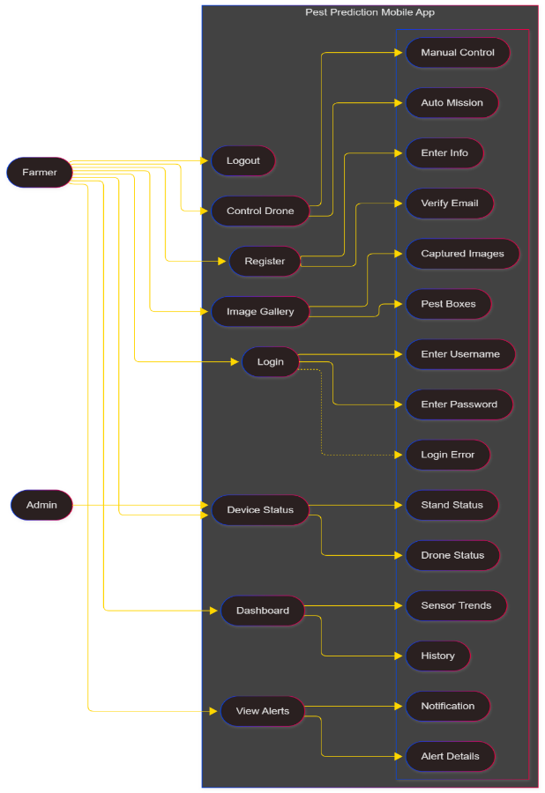

Figure 3.3 – Mobile App Use Case Diagram

* 1. **Mobile App Use Case Descriptions**
     1. **App Use Case : Drone Control via App**

| **Field** | **Description** |
| --- | --- |
| **Use Case ID** | AUC-01 |
| **Use Case** **Name** | Drone Control Through Mobile App |
| **Actor** | Farmer |
| **Precondition** | User is logged into the app; drone and Raspberry Pi are powered and connected. |
| **Postcondition** | Drone performs commanded action such as takeoff, landing, movement, or image capture. |
| **Basic Flow** | The farmer opens the app, accesses the drone control panel, and interacts with the on-screen buttons. Commands are sent to the Raspberry Pi which forwards them to the drone. The drone acknowledges movement and streams status updates back to the app. |
| **Alternative Flow** | The farmer selects automatic mission mode instead of manual control. |
| **Exceptions** | Weak network, command delay, drone battery warning, or loss of GPS. |

* + 1. **App Use Case: Viewing Pest Alerts**

| **Field** | **Description** |
| --- | --- |
| **Use Case ID** | AUC-02 |
| **Use Case Name** | View and Receive Pest Alerts |
| **Actor** | Farmer |
| **Precondition** | Prediction engine generates an alert and the user has notification permissions enabled. |
| **Postcondition** | Alert details such as risk level, images, and recommended action appear in the app. |
| **Basic Flow** | The app receives a push notification. The farmer taps it to open the alert screen and views details including sensor graphs and evidence images. |
| **Alternative Flow** | App is offline; alerts are queued and displayed once online. |
| **Exceptions** | Notification delivery failure or cloud downtime. |

* + 1. **App Use Case: Dashboard Viewing**

| **Field** | **Description** |
| --- | --- |
| **Use Case ID** | AUC-03 |
| **Use Case Name** | View Dashboard and Trends |
| **Actor** | Farmer |
| **Precondition** | Sensor data and prediction logs exist in the cloud database. |
| **Postcondition** | Charts, graphs, and field analytics are displayed in the dashboard. |
| **Basic Flow** | The farmer navigates to the dashboard, selects field and time range, and views charts showing moisture, temperature, humidity, and historical risk trends. |
| **Alternative Flow** | Device offline → cached data is shown. |
| **Exceptions** | Database query error or missing historical records. |

* + 1. **App Use Case: Image Gallery Viewing**

| **Field** | **Description** |
| --- | --- |
| **Use Case ID** | AUC-04 |
| **Use Case Name** | View Drone-Captured Images |
| **Actor** | Farmer |
| **Precondition** | Images are already uploaded to cloud storage after the drone mission. |
| **Postcondition** | Images with annotations and details appear in the gallery. |
| **Basic Flow** | The farmer opens the gallery, browses images, zooms into details, and views model-detected bounding boxes. |
| **Alternative Flow** | User filters images by pest type or mission date. |
| **Exceptions** | Image loading failures or corrupted stored files. |

* + 1. **App Use Case: Device Status Monitoring**

| **Field** | **Description** |
| --- | --- |
| **Use Case ID** | AUC-05 |
| **Use Case Name** | Monitor Device Status |
| **Actor** | Farmer / Admin |
| **Precondition** | All devices periodically send health status to the cloud. |
| **Postcondition** | Device connectivity, battery, and internal health are shown in the app. |
| **Basic Flow** | The farmer opens the Device Status section and views online/offline indicators, battery levels, and warning messages. |
| **Alternative Flow** | Admin performs maintenance actions or schedules a firmware update. |
| **Exceptions** | Device becomes unreachable or sends invalid status data. |

**4. References**

Smith, J.; Doe, A., “Drone-based pest detection for precision agriculture.”  
<https://doi.org/10.3390/s22093289>

Adafruit, “DHT22 temperature-humidity sensor datasheet.”  
 <https://www.adafruit.com/product/385>

TensorFlow, “TensorFlow Lite: Deploy machine learning models on edge devices,”   
<https://www.tensorflow.org/lite>

OpenWeather, “OpenWeather API documentation.”   
 <https://openweathermap.org/api>

Raspberry Pi Foundation, “Raspberry Pi 5 specifications and documentation.”   
<https://www.raspberrypi.com/documentation>

DJI, “DJI Developer Documentation for Flight Control.”   
<https://developer.dji.com/documentation>

Espressif Systems, “ESP32 Technical Reference Manual,”   
 <https://www.espressif.com/en/support/documents/technical-documents>

Google Developers, “Flutter Development Documentation,”

<https://docs.flutter.dev>

Singh, R.; Kumar, L., “AI-enabled pest prediction using environmental sensing.”  
 <https://ieeexplore.ieee.org/document/9359322>